13. Write a Pandas program to detect missing values of a given DataFrame. Display True or False.

Algorithm
- Import the pandas and numpy libraries.
- Create a DataFrame with sample data.
- Insert some missing values (NaN) into the DataFrame.
- Use the isnull() function to detect missing values.
- Display the result (True for missing values, False otherwise)

Python Code
import pandas as pd
import numpy as np

data = {
'ord_no':[70001, np.nan, 70002, 70004, np.nan],
'purch_amt':[150.5, 270.65, 65.26, 110.5, 948.5],
'ord_date':['2012-10-05','2012-09-10',np.nan,'2012-08-17','2012-09-10'],
'customer_id':[3002,3001,3001,3003,3002],
'salesman_id':[5002,5003,np.nan,5001,5002]
}

df = pd.DataFrame(data)

print("Original DataFrame:\n")
print(df)

print("\nMissing Values (True/False):\n")
print(df.isnull())

Sample Input
ord_no purch_amt ord_date customer_id salesman_id
70001 150.50 2012-10-05 3002 5002
NaN 270.65 2012-09-10 3001 5003
70002 65.26 NaN 3001 NaN
70004 110.50 2012-08-17 3003 5001
NaN 948.50 2012-09-10 3002 5002

Sample Output
Original DataFrame:

ord_no purch_amt ord_date customer_id salesman_id
0 70001.0 150.50 2012-10-05 3002 5002.0
1 NaN 270.65 2012-09-10 3001 5003.0
2 70002.0 65.26 NaN 3001 NaN
3 70004.0 110.50 2012-08-17 3003 5001.0
4 NaN 948.50 2012-09-10 3002 5002.0

Missing Values (True/False):

ord_no purch_amt ord_date customer_id salesman_id
0 False False False False False
1 True False False False False
2 False False True False True
3 False False False False False
4 True False False False False

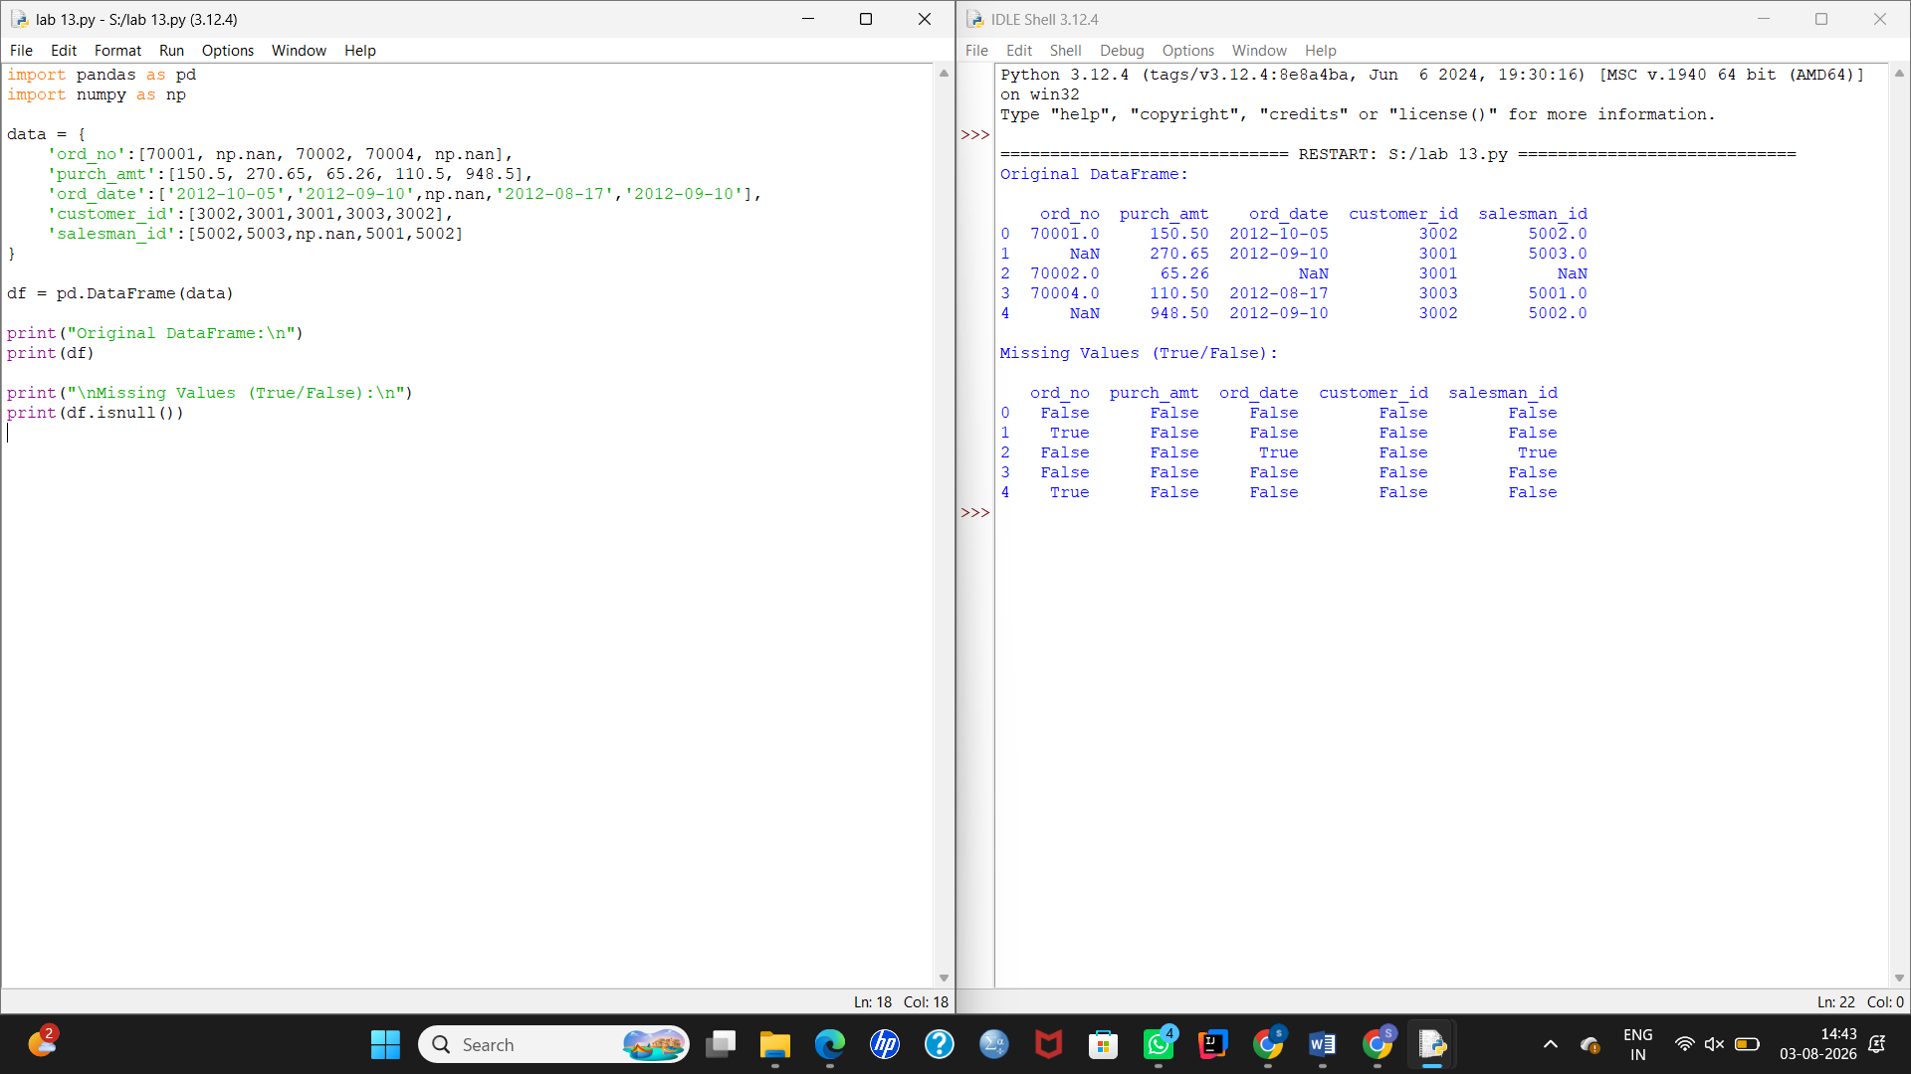

14. Write a Pandas program to find and replace the missing values in a given DataFrame.

Algorithm
- Import the pandas and numpy libraries.
- Create a DataFrame with missing values (NaN).
- Display the original DataFrame.
- Use the fillna() function to replace missing values.
- Display the updated DataFrame.

Python Code
import pandas as pd
import numpy as np

data = {
'ord_no':[70001, np.nan, 70002, 70004, np.nan],
'purch_amt':[150.5, 270.65, 65.26, 110.5, 948.5],
'ord_date':['2012-10-05','2012-09-10',np.nan,'2012-08-17','2012-09-10'],
'customer_id':[3002,3001,3001,3003,3002],
'salesman_id':[5002,5003,np.nan,5001,5002]
}

df = pd.DataFrame(data)

print("Original DataFrame:\n")
print(df)

df = df.fillna(0)

print("\nDataFrame after replacing missing values:\n")
print(df)

Sample Input
ord_no purch_amt ord_date customer_id salesman_id
70001 150.50 2012-10-05 3002 5002
NaN 270.65 2012-09-10 3001 5003
70002 65.26 NaN 3001 NaN
70004 110.50 2012-08-17 3003 5001
NaN 948.50 2012-09-10 3002 5002

Sample Output
